Raysync Server Port Unification Documentation

Background
Raysync server is composed of multiple module services, including: Web user portal service, Web admin portal service, Websocket transfer service, HTTP download service, High-Speed transfer service, Node management service.
Each module service requires one or more physical ports. The number of ports opened by the current deployment of Raysync is large. Therefore, the requirement of port unification is proposed, and only one port (such as: 443) is opened to reduce the possibility of network attacks.

Implementation method
Take the deployment of a single Raysync server as an example: nginx listens to port 443 as a proxy forwarding service, resolves different domain name requests, and forwards the requests to the internal Raysync service module.

Example steps

1. Domain application
Take port 443 as an example, the resource list is as follows

NO. | Domain | External IP | External Ports | Forwarding | Intranet IP | Internal port/protocol type | Description
1 | admin.raysync.cn | 120.76.133.207 | 443 | Nginx | 127.0.0.0 | TCP/9091 | Raysync admin portal
2 | web.raysync.cn | 120.76.133.207 | 443 | Nginx | 127.0.0.0 | TCP/8091 | Raysync user portal
3 | websocket.raysync.cn | 120.76.133.207 | 443 | Nginx | 127.0.0.0 | TCP/2481 | The port for displaying file lists on the user portal and webscoket upload
4 | httpdownload.raysync.cn | 120.76.133.207 | 443 | Nginx | 127.0.0.0 | TCP/2483 | Web page download on the user portal
5 | udp.raysync.cn | 120.76.133.207 | 443 | Nginx | 127.0.0.0 | UDP/32001 | Raysync high-speed transfer protocol port

Build nginx

1） Install dependency packages
yum -y install gcc zlib zlib-devel pcre-devel openssl openssl-devel

2） Download Nginx and unzip the installation package
cd /usr/local
mkdir nginx # Create a folder
cd nginx
wget http://nginx.org/download/nginx-1.13.7.tar.gz # Download nginx
tar -xvf nginx-1.13.7.tar.gz # Uzip

3） Install nginx
cd /usr/local/nginx # Enter the nginx directory
cd nginx-1.13.7
./configure # Exucute configure
make # Exucute make
make install # Exucute make install

4） Configure nginx.conf
vi /usr/local/nginx/conf/nginx.conf

Modify the configuration to the following
#user nobody;
worker_processes 1;

#error_log logs/error.log;
#error_log logs/error.log notice;
#error_log logs/error.log info;

#pid logs/nginx.pid;

events {
worker_connections 1024;
}

stream {

log_format proxy '$remote_addr [$time_local] '
'$protocol $status $bytes_sent $bytes_received '
'$session_time $upstream_addr '
'$upstream_bytes_sent $upstream_bytes_received $upstream_connect_time';

upstream raysync_udp {
hash $remote_addr consistent;
server 127.0.0.1:32001;
}

server {
listen 443 udp bind reuseport;
proxy_pass raysync_udp;
access_log logs/udp_raysync.log proxy;
}

}

http {
server_names_hash_bucket_size 64;
include mime.types;
default_type application/octet-stream;

log_format main '$remote_addr - $remote_user [$time_local] "$request" '
'$status $body_bytes_sent "$http_referer" '
'"$http_user_agent" "$http_x_forwarded_for"';

#access_log logs/access.log main;
# log_format proxy '$remote_addr [$time_local] '
# '$protocol $status $bytes_sent $bytes_received '
# '$session_time $upstream_addr '
# '$upstream_bytes_sent $upstream_bytes_received $upstream_connect_time';

sendfile on;
#tcp_nopush on;

#keepalive_timeout 0;
keepalive_timeout 65;

#gzip on;

server {
listen 443 ssl;
server_name web.raysync.cn;

ssl_certificate /home/admin/raysync.cn.pem;
ssl_certificate_key /home/admin/raysync.cn.key;

location / {
add_header 'Access-Control-Allow-Origin' '*';
proxy_pass https://127.0.0.1:8091;
}
}

server {
listen 443 ssl;
server_name admin.raysync.cn;

ssl_certificate /home/admin/raysync.cn.pem;
ssl_certificate_key /home/admin/raysync.cn.key;

location / {
add_header 'Access-Control-Allow-Origin' '*';
proxy_pass https://127.0.0.1:9091;
}
}

server {
listen 443 ssl;
server_name httpdownload.raysync.cn;
ssl_certificate /home/admin/raysync.cn.pem;
ssl_certificate_key /home/admin/raysync.cn.key;

location / {
add_header 'Access-Control-Allow-Origin' '*';
proxy_pass http://127.0.0.1:2482;
}
}

server {
listen 443 ssl;
server_name websocket.raysync.cn;
ssl_certificate /home/admin/raysync.cn.pem;
ssl_certificate_key /home/admin/raysync.cn.key;
access_log logs/websocket_raysync.log main;
location / {
add_header 'Access-Control-Allow-Origin' '*';
proxy_pass http://127.0.0.1:2480;
proxy_http_version 1.1;
proxy_set_header Upgrade $http_upgrade;
proxy_set_header Connection "upgrade";
proxy_set_header Host $host;
}
}

}

5） Put the certificate files into the nginx configuration directory
1. Put the certificate file in the /home/admin directory (the nginx configuration directory is /home/admin)

6） Start nginx
./nginx -c /usr/local/nginx/conf/nginx.conf

The error that may occur during startup is because these two modules were not added during make

Add related modules and make once
./configure --with-stream --with-http_ssl_module
make && make install

Restart nginx
./nginx -c /usr/local/nginx/conf/nginx.conf

Deploy Raysync service and modify server configuration
- Deploy the Raysync server by execute ./install.sh (if the deployment is successful, you can ignore this step. If the service has been started, you need to execute ./stop.sh to stop the Raysync service first).

- Modify the Raysync/config/config.ini file.

websocket_domain = websocket.raysync.cn
ng_websocket_ssl_port = 443
httpdownload_domain = httpdownload.raysync.cn
ng_httpdownload_ssl_port = 443
udp_proxy_domain = udp.raysync.cn

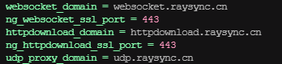

3.Start Raysync server ./start.sh
Visit Raysync admin portal: https://admin.raysync.cn/admin
Visit Raysync user portal: https://web.raysync.cn/signin

4.Change the udp port of Raysync is 443, and restarted service.
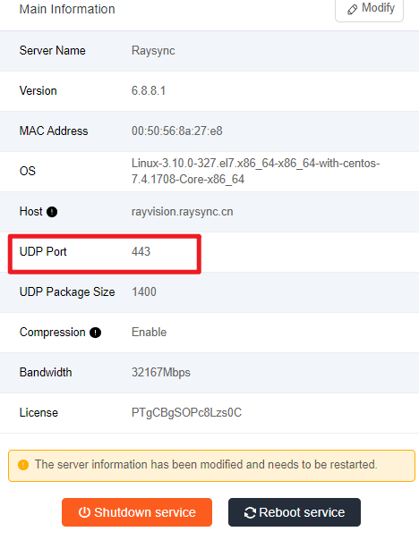

5.Verify whether the client transfer and web page transfer can be transmitted normally. If the normal transfer can be used normally, the port unification configuration is successful.

